Experiment 1

Aim : Design a web page using Text level and Block level elements in HTML

HTML means Hyper Text Markup Language.

Tags :

<html> | Specifies an html document
<head> | Specifies information about the document
<title> | Specifies the document title
<body> | Specifies the body element
<h1> to <h6> | Specifies header 1 to header 6
<p> | Specifies to show browsers that do not support the ruby element
align | Horizontally aligns tags

Code :

<html>
<head>
<title>First Experiment</title>
</head>
<body>
<h1 align="center">Welcome to the HTML Page</h1>
<h2 align="center">HTML means Hyper Text Markup Langauge.</h2>
<h3 align="center">HTML is used for to develop the web pages.</h3>
<h4 align="center">HTML is the Sketlon of WebPage</h4>
<h5 align="center"> A. Chandu Mani Kumar ( 16CS036 ) </h5>
<h6 align="center"> Lingaya's Vidyapeeth </h6>
<p align="center"> Faridabad </p>
</body>
</html>

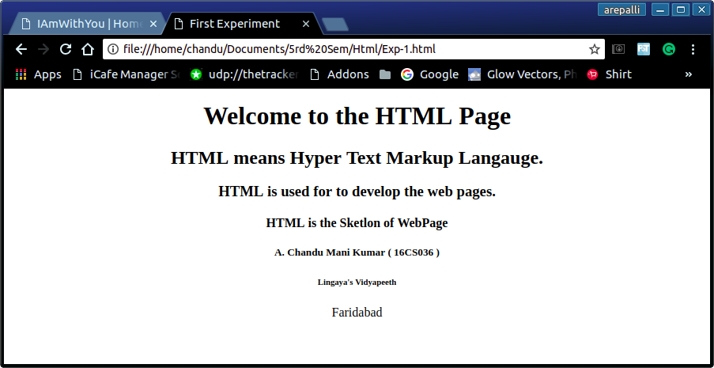
Output :

